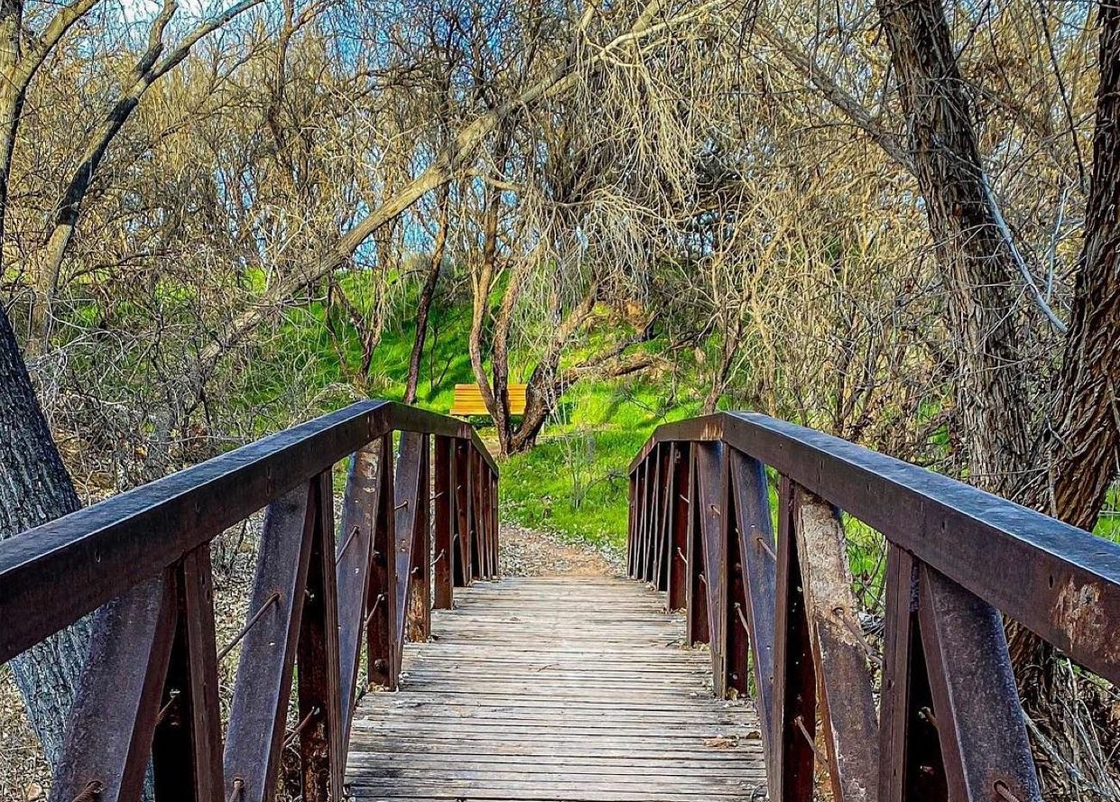
Dead Horse Ranch State Park
675 Dead Horse Ranch Road
Cottonwood, AZ 86326

Dear Couple:

Thank you for considering Dead Horse Ranch as the location for your wedding.

The enclosed material will help you decide if an Arizona State Park will be the best backdrop for your wedding. The material includes information on wedding sites and facilities for weddings and receptions. Please contact us by phone for available dates or to answer any questions you may have.

Attached you will find an application, price packages, frequently asked questions and rules and regulations. Applications/forms should be completed and returned to Fort Verde by fax or in person, as soon as possible.

Payment is due at the time a reservation is made with a Visa, Mastercard or cash.

PLEASE NOTE:
- Arizona State Parks Rules and Regulations will be observed.
- Proposed changes in your schedule or activities must be pre-approved by the park manager or his/her representative.

The park manager may assess up to a $250 fee for damages and cleanup when, in his/her judgment, facilities are not left in the same condition as when the activity commenced. The park is not responsible for providing medical, sanitary or security services during the term of the reservation.

Thank you again for considering Dead Horse Ranch. We are looking forward to working with you. Please feel free to call us if you have any questions.

Sincerely,

Staff at Dead Horse Ranch State Park
Office: (928) 634-5283
Fax: (928) 639-0417

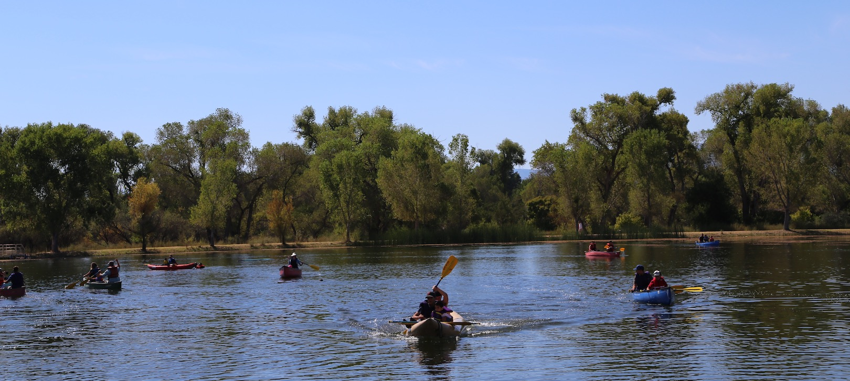

Dead Horse Ranch State Park
675 Dead Horse Ranch Road
Cottonwood, AZ 86326
(928) 634-5283

FACILITY RENTAL INFORMATION
Dead Horse Ranch State Park is pleased to make its amenities available to you. To help you make your
decision regarding the use of the Park, we ask that you study our guidelines carefully. Your cooperation is
needed in complying with the following regulations to ensure the success of your event, the security of the
facilities and the protection of the surrounding natural environment.

Special Use Permits
Arizona State Parks mission is to manage and conserve Arizona’s natural, cultural and recreational
resources for the benefit of the people, both in our Parks and through our Partners. Depending on the event
size, location, date, resources required (traffic control, EMT, etc.), some facility rentals might require a
Special Use Permit. These events require a minimum 14-day advance reservation, with fees & requirements
that vary depending on the size, scope, date, and use of park staff. A Special Use Permit will define the
rental space, what is included, what is excluded, any exceptions or variance from standard policy, and what
is required, such as damage or cleanup deposits, liability insurance, medical services, sanitary services,
security services, etc. One of the Park’s staff members will be designated as your primary contact to answer
questions or provide assistance while planning and running the event.
Special Use Permits are required for weddings. If you are planning a wedding, please see “Additional
Information for Wedding Planners” on page 5 of this document.

Reservations
Reservations for your event, whether a birthday party, wedding ceremony, reception or any event are on a
first come first serve basis. For groups expected to be over 20 individuals, a valid credit card will be
required.
Reservation Fee
A reservation fee of $5.00 is due at the time of booking. This fee is non-refundable and non-transferable.

Rental Hours
Unless a variance is granted (usually per Special Use Permit) the Park facilities will be available only
during normal hours. All events must end by 10 P.M.

Rental Space & Inclusions
The reserved area is rented “as is.” Rental includes exclusive use of the following: Ramada, picnic tables,
adjoining grills.

Rental Fees & Payment Policy
The reservation areas are normally rented/billed for specific time periods. (For example: 8 am – 5 pm.)
Management can approve adjustment of these time periods and related billing to suit the needs of the renter
(usually per Special Use Permit). Balance of all charges is due 30 days prior to the event. No tax or service
charge will be applied to the rental fees. All deposits and payments may be made in the form of cash,
cashier’s checks, credit cards or debit cards. Personal checks are not accepted for events.

Inclement Weather
The Park assumes no liability for occurrences outside the Parks’ control, including inclement weather or
any other occurrence that may affect or impact the event. You are responsible for any additional rentals
needed to accommodate the event, regardless of when the need becomes apparent.

Postponement of Event
Any change in the event date must be agreed to in writing by both Arizona State Parks and Permittee and
will result in a modification of the contract price to conform with the current rates. In the event all parties
agree to change the event date, all payments previously made towards the rental of the facility shall be
credited toward any remaining or additional charges.

Cancellation Policy
If a cancellation occurs fewer than 30 days in advance of the event, all deposits and fees are non-refundable
and no refund will be granted. Any cancellations made prior to 30 days before the event, will receive a
refund for any fees paid, excluding the non-refundable reservation fee of $5.00. Payments for events that
are transferred (from one date to another) are non-refundable regardless of cancellation date. Refund checks
will be mailed within 90 days of receipt of cancellation.

Event Representative
A responsible party must be designated as the Event Representative prior to the start of the event. It is the
representative’s responsibility to make sure that all participants, including service providers and vendors
adhere to park policies. It will be the responsibility of the Event Representative to be available to answer
questions and assist Park staff in enforcing all rules and regulations, as well as making contact with a Park
staff member at the end of the event before vacating the facility. (If the Event Representative becomes
intoxicated at any point during the event, the Park Manager may terminate the event as a breach of
contract.) The Event Representative must be at the Park during the entirety of the event.

Park Staff
Park Staff is always on premises during regular hours of operation. Park staff will provide assistance to
ensure event meets specifications outlined in the Special Use Agreement.

Vendors/Caterers
The Park provides only the venue. All costs of food, floral, rentals, entertainment, etc., are your
responsibility. Arizona State Parks does not promote or provide information regarding private business.
After you select your service providers, key contact names and phone numbers of the vendors shall be
provided to the Park. Any caterer or professional food provider must possess a Yavapai County Food
Handler’s Permit.

Photography
Photography not intended to make profit is permitted throughout the Park.

Flora & Fauna
Our mission statement says, “Managing and conserving Arizona’s natural, cultural and recreational
resources for the benefit of the people”. We take this very seriously. As a public resource, we ask all guests
to show the utmost respect for all forms of plants and wildlife so that our environment may be preserved
intact for all to enjoy. All guests must stay on designated trails and roadways to protect the native flora of
the Park. Trimming, cutting or altering of any plants or trees can be extremely damaging and is not
allowed. For the safety of the wildlife and plants near the Park, please do not throw rice, birdseed, confetti
or similar materials. Hunting, fishing, handling, harassing or disturbing the wildlife is not permitted. Please
leave the grounds as you found them.

Special Event Equipment
You are responsible for ensuring that vendors provide sufficient extension cords, generators, etc. to cover
the event’s electrical needs. Failure to notify Park staff of electrical requirements may result in inadequate
power or power failure.

Deliveries (Personal and Rental)
All deliveries and pick-ups must be arranged with the Park staff. The Park does not have areas for the
storage of personal belongings or rental equipment. Therefore, all deliveries of supplies and equipment
must occur no sooner than the day before the event with advanced notice of time of delivery, unless special
arrangements have been made prior to the event. Deliveries and pick up of rental equipment must be made
during park operating hours. Park staff will not sign for personal or rented supplies and equipment. If a
vendor requires a signature upon delivery, a responsible party must be available to sign the delivery slip.
Arizona State Parks or any Park staff is not responsible for loss or damage to property brought onto the
premises and is not responsible for set up or dismantling of any equipment. All rental equipment must be
scheduled for pick up by 11am the morning following the event, unless special arrangements have been
made prior to the event.

Equipment belonging to the Park
Depending upon availability, banquet tables and chairs may be rented for an additional fee.

Shade Structures
Shade structures, tents, pop-ups, canopies, etc., must be erected & secured in a safe manner, free of any
contact with park structures or flora.
Decorations
No silk flowers, birdseed or tape may be used and no physical alterations to the Park or its facilities may be
made. Confetti and Piñatas are not permitted. No doorway or public corridor may be blocked in any way.

Minors
Adults must accompany minors at all times. The adults are responsible for the minors’ safety and
discipline.

Pets
Pets are permitted. It is important to note that Cottonwood City Ordinance (§ 592), Yavapai County Animal
Control Ordinance (§ 2000-3), Arizona State Law (A. R. S. § 11-1001 - 1029), and Arizona State Parks
Regulation (R12-8-115), all require that pets be restrained on a leash no more than six feet in length and/or
are otherwise kept in control. Leash laws are strictly enforced.

Noise Restrictions
Noise generated by the event may not exceed a level satisfactory to guests and Park staff. A level of noise
or music deemed disruptive or diminishes the enjoyment of the Park by other Park users, or that is
disturbing to wildlife may be deemed due cause to terminate the event. Quiet hours must be observed
starting at 10 p.m.
DJs, live music, or sound amplification must be specifically approved in the rental agreement or Special\
Use Permit.

Alcohol / Tobacco / Firearms
Alcohol is permitted and liquor laws are enforced per Arizona Revised Statutes Title 4. Smoking is
prohibited indoors and within 20 feet of any entrance or exit (§36-601). Please provide cigarette receptacles
for your guests. Pursuant to Arizona Revised Statutes Title 13, carrying of firearms is permitted. However,
no consumption of alcohol is permitted if carrying a weapon.

Cleanup/Damage
You are responsible for returning the rented area to original condition. All rental items, decorations,
flowers, personal belongings, etc. must be removed from the public areas immediately following the event
and be picked up from the Park by midnight unless otherwise arranged with the Supervisor on duty. The
Park staff will remove any equipment (i.e. tables, chairs, etc.) belonging to the Park by prior arrangement
only. The Park staff will not be responsible for the set-up or removal of equipment. Any decorations or
personal items remaining from the event will be removed by the Park staff and may be destroyed, sold or
otherwise disposed of without any liability to the Park. If any damage or theft has occurred, the Permittee
will be contacted immediately. The Park will determine the amount to be billed to the Permittee. The
caterer is responsible for clean up during and after the event. If the caterer cannot, for any reason, provide
full clean up, the Permittee is responsible for contracting a cleanup service. When a caterer is not used, the
Permittee assumes the responsibility of the caterer and cleanup. Charges for unusual cleanup after the
event will be billed to the Permittee.

Additional Information for Wedding Planners
Permits
In the case of weddings, a Wedding Special Use Permit Application must be completed, signed and
returned to the Park. Yavapai County & the City of Cottonwood do not require any event permits.

Facilities
There are three day use areas suitable for weddings: the River Day Use Area on Owl Road (two large
ramadas); the terraces by our West Lagoon; and the Los Alamos Day Use Area between the middle and
east lagoons. The group campground is an option if no other events are planned for that area. These areas
all include restroom buildings (modern restrooms cleaned and stocked daily). It is recommended that the
reservation be made as far in advance as possible – in our case, up to one year. For example, April & May
are popular months for weddings because of temperatures and weather. At that time the Park also
experiences peak visitation. Those who attempt to reserve facilities at the last moment frequently find that
our facilities are fully booked.

Rehearsal
The Park will allow a rehearsal of up to one hour in duration at no extra charge. Rehearsals must take place
during park operating hours.

Seating
At this time we do not rent tables or chairs.

Music
Amplified music, DJs, and live music are not allowed unless agreed to in the special use permit.

Setup
You may begin setup during normal daylight hours on the day of the event. Restrooms/Dressing Rooms
All of the Park’s restroom facilities are ADA accessible. We do not have dressing rooms.

Parking
The rental areas all have parking proportional to their capacity. Additional parking is available, but may
require a short walk or shuttle by the wedding party.

ADA Access
With the exception of the terrace area, all of the Day Use Areas are ADA accessible.

Overnight Accommodations
The park has 17 tent camping sites, over 125 RV camping sites, and 8 cabins, all of which are reservable
online.

Frequently Asked Questions for Weddings at Tonto Natural Bridge

1. Q: How many guests can the area comfortably accommodate?
A: There are (3) day use areas where weddings can be held. The Lower day use area on Owl Road
has two large ramadas, the terraces by our West Lagoon and the day use area between the middle
and east lagoon. The group campground is an option if no other events are planned for that area.
Depending on the area park can accommodate small or large weddings up to 200+ guests.

2. Q: Can the Park host more than one event at a time?
A: Yes.

3. Q: At what times may events be held?
A: Any time of year between the hours of 8am to 9pm as long as another event is not already
scheduled for that facility.

4. Q: What does the facility rental fee include?
A: Depends on area and wedding party needs.

5. Q: Can I rent the facility for a ceremony only?
A: Yes

6. Q: In case of inclement weather, what happens to an outdoor wedding?
A: There is no alternative building for covered shelter only ramadas rented by the group. We
recommend that the wedding party make alternative preparations in this event to include tent rental,
other facilities, etc.

7. Q: Is outside catering allowed?
A: Yes, you may choose most any caterer for your event upon approval by the Park. All caterers
must be able to provide proof of liability insurance to the Park. A professional caterer is not
required, however, at least one member of your kitchen personnel must hold a current Yavapai
County Food Handlers Card.

8. Q: Is there a specific list of other vendors?
A: For food catering no. There are many options available in the Verde Valley.

9. Q: Are tables, chairs & linens included?
A: No, but a wedding kit including these items is available for an additional fee if reserved.

10. Q: What is your alcohol policy?
A: No hard liquor is permitted on the premises. Only beer, wine, champagne and malt beverages
(like wine coolers) are allowed.

11. Q: Is smoking permitted?
A: There is no smoking permitted inside any of our buildings, however, smoking is allowed outside
at least 20 feet away from an exit. (Please provide cigarette receptacles for your guests.)

12. Q: Is music allowed?
A: No DJ or live band is allowed at this time, no amplified equipment is permitted unless something
is agreed to in the special use permit.

13. Q: When can I start setting up for my event?
A: Whatever time deemed necessary by the organizers on the day of the event. Must be completed
during normal daylight hours.

14. Q: Are there any restrictions on decorations?
A: Yes, no physical alterations may be made to any part of the Park’s facilities or property. If
unsure, first clear with management of the Park.

15. Q: What restrooms are available for event guests?
A: Any restroom facility in the selected area of the event.

16. Q: Is there a dressing room?
A: No

17. Q: Is there parking?
A: Each area available does have some parking, however it varies by area. Additional parking is
available, but would require a short walk or shuttle by wedding party.

18. Q: Is there handicap access?
A: Yes, in most areas, except in the terrace area.

19. Q: How do I book an event and hold the date?
A: All reservations are made on a first-come first-serve basis. To secure a reservation, a Wedding
Special Use Permit Application must be completed, signed and returned to the park. Also, a nonrefundable
reservation deposit is due at the time of booking, which will be applied towards the total
balance.

20. Q: What forms of payment do you accept?
A: A credit card (Visa or MasterCard only) is the preferred form of payment for refund purposes
and damage payment. A check or cash payment can be made, however refund would have to be
made via check, which can take up to two weeks.

21. Q: When is payment due?
A: The reservation deposit is due at time of booking and is nonrefundable. The remaining balance
of your event is due 30 days prior to the event date.

22. Q: How far in advance do you need to make reservations?
A: The sooner the better, as requests are considered on a “first come, first serve” basis. Reservations
can be made up to one year in advance.

23. Q: Do you offer overnight accommodations?
A: The park has 8 cabins and camping facilities available for advance reservation.

24. Q: Are weapons allowed at your venue?
A: Yes, due to our state laws. However no consumption of alcohol is permitted if carrying a
weapon.

25. Q: Are there adequate bathroom facilities for large groups?
A: Our campground restrooms can serve large groups, but there is not a changing room available.

26. Q: Are any other permits required from the city/county?
A: No.

27. Q: What is your policy for dress rehearsals? Are the wedding party allowed to use the facility for
this purpose prior to the wedding?
A: Yes, upon availability and prior arrangements with park management.

28. Q: Is there an extra charge for any amenities/facilities?
A: It is all dependent on Wedding Special Use permit and agreement of the permit.

29. Q: Is there a cleaning fee?
A: No, as the party is required to leave the area the way they found it. A cleaning fee could be
charged if not left in good condition or a damage fee could be applied.

Thank you for considering using Dead Horse Ranch State Park for your wedding ceremony!

