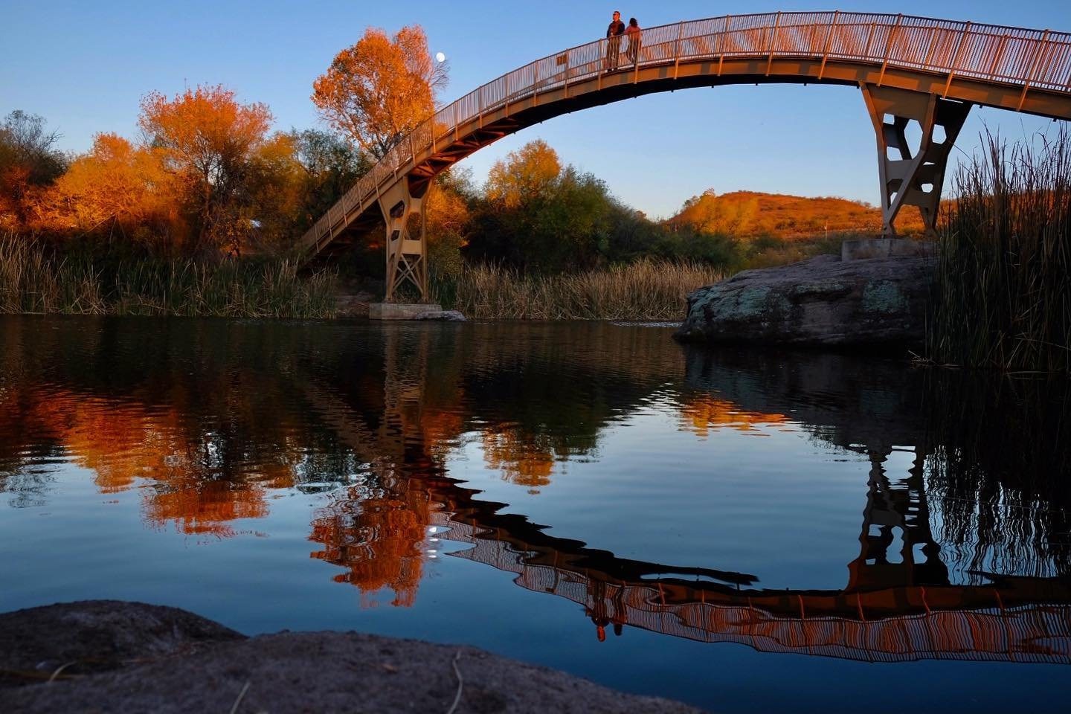
Patagonia Lake State Park
HC2 Box 273
Nogales, AZ 85621

Dear Couple:

Thank you for considering Patagonia Lake as the location for your wedding.

The enclosed material will help you decide if an Arizona State Park will be the best backdrop for your wedding. The material includes information on wedding sites and facilities for weddings and receptions. Please contact us by phone for available dates or to answer any questions you may have.

Attached you will find an application, price packages, frequently asked questions and rules and regulations. Applications/forms should be completed and returned to Fort Verde by fax or in person, as soon as possible.

Payment is due at the time a reservation is made with a Visa, Mastercard or cash.

PLEASE NOTE:
- Arizona State Parks Rules and Regulations will be observed.
- Proposed changes in your schedule or activities must be pre-approved by the park manager or his/her representative.

The park manager may assess up to a $250 fee for damages and cleanup when, in his/her judgment, facilities are not left in the same condition as when the activity commenced. The park is not responsible for providing medical, sanitary or security services during the term of the reservation.

Thank you again for considering Patagonia Lake. We are looking forward to working with you. Please feel free to call us if you have any questions.

Sincerely,

Staff at Patagonia Lake State Park
Office: (520) 287-6965
Fax: (520) 287-5618

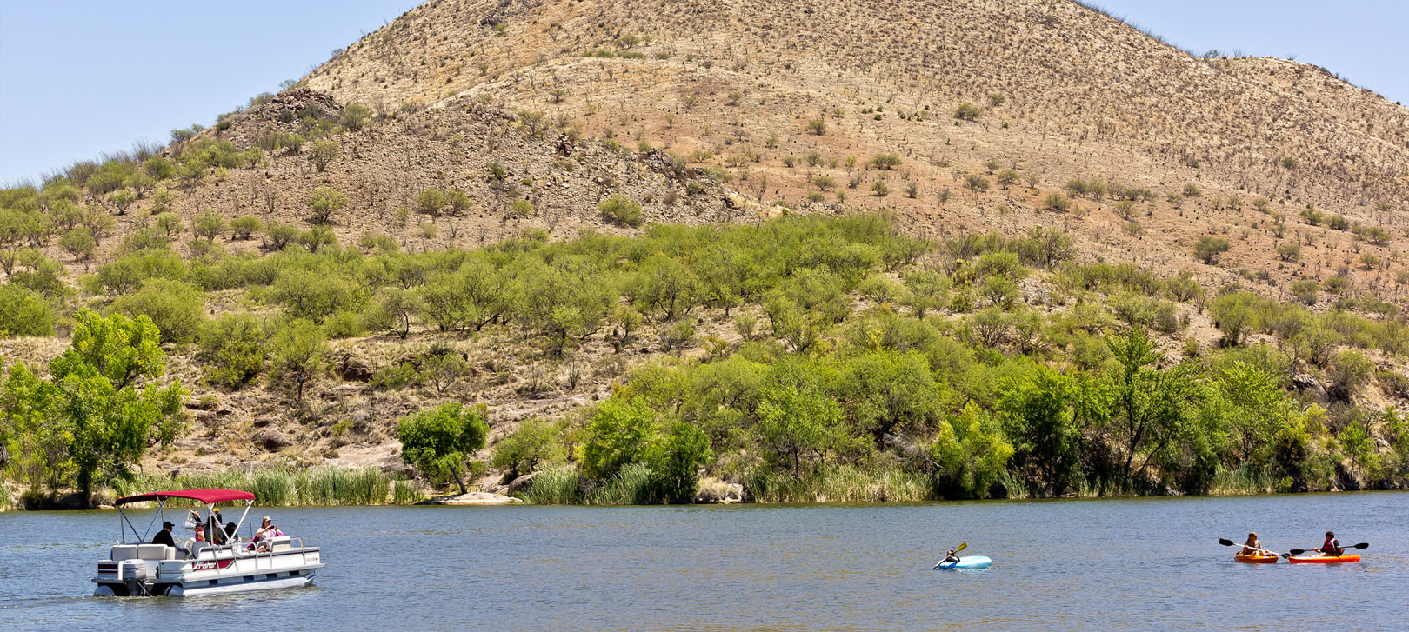

Patagonia Lake State Park
400 Patagonia Lake Road
Patagonia, AZ 85624
(520) 287-6965

FACILITY RENTAL INFORMATION
Patagonia Lake State Park is pleased to make its amenities available for your special event. To help you
make your decision regarding the use of the park, we ask that you study our guidelines carefully. Your
cooperation is needed in complying with the following regulations to ensure the success of your event, the
security of the facilities and the protection of the surrounding natural environment.

Reservations
Reservations for wedding ceremonies, receptions and other rentals are on a first come first serve basis. The
Point-Day Use Ramada requires you make reservations at least 24 hours in advance.
Some facility rental requires that you apply for a Special Use Permit. These events require a minimum 14
day advance reservation. Contact the park’s Event Coordinator for more information.

Reservation Fee
For the Point Day Use Ramada a fee of $20.00 plus a reservation fee of $5.00 are due at the time of
booking. This fee is non-refundable and non-transferable.
Some facility rental requires that you apply for a Special Use Permit. These events fees will vary
depending on the size and scope of the event, contact the park’s Event Coordinator for detailed information
about fees.

Special Use Permit
Arizona State Parks mission is to manage and conserve Arizona’s natural, cultural and recreational
resources for the benefit of the people, both in our Parks and through our Partners. Therefore to hold a
special event at the facility, Arizona State Parks requires a Special Use Permit. This agreement must be
completed, signed and returned to the Park at the time of booking your event.

Rental Space & Inclusions
The Day Use Ramada has 12 large picnic tables and a large 4’ grill that will be reserved just for your
party’s use. There is also plenty of parking and a restroom building that can accommodate large parties.
The reserved area is rented “as is”.
If your event requires a Special Use Permit what rental space and what is included with the fee will vary
depending on the event size, location, date, resources required (i.e. traffic control, EMT, etc…), and
cleanup costs. The park will designate the park’s Event Coordinator to be your primary contact for any
planning questions and during the hours of your event.

Rental Hours
Renting the Point Day-Use Ramada includes a full day’s rental, from 8am to 9 p.m.
An event requiring a Special Use Permit can be held any time between 8 a.m. and 9 p.m.

Rental Fees & Payment Policy
Full payment for the Point Day-Use Ramada is due upon making the reservation.
For events requiring a Special Use Permit, the rental fees and payments will depend on the size, scope,
date, and use of park staff. A clean up and damage refundable deposit is also required. There will also be a
cleanup and damage refundable deposit. Contact the Park’s Events Coordinator for details.
All deposits and payments may be made in the form of cash, credit cards, or debit cards.

Postponement of Event
Any change in the event date must be agreed to in writing by both Arizona State Parks and Permittee and
will result in a modification of the contract price to conform to the current rates. In the event all parties
agree to change the event date, all payments previously made towards the rental of the facility shall be
credited toward any remaining or additional charges.

Cancellation Policy
If a cancellation occurs fewer than 48 hours in advance of the event, all deposits and fees are nonrefundable
and no refund will be granted. Any cancellations made prior to 48 hours before the event, will
receive a refund for any fees paid, excluding the non-refundable reservation fee of $5.00. Payments for
events that are transferred (from one date to another) are non-refundable regardless of cancellation date.
Refund checks will be mailed within 6-8 weeks of receipt of cancellation.

Inclement Weather
The Park assumes no liability for inclement weather that affects the event or for any occurrence that may
impact the event, which is outside the Parks’ control. You are responsible for any additional rentals
required to accommodate the needs of the event.

Event Representative
A responsible party must be designated as an Event Representative prior to the start of the event. The Event
Representative may be neither the bride nor groom. It will be the responsibility of the Event Representative
to be available to answer questions and assist park staff in enforcing all rules and regulations and (s)he
must check out with a park staff member at the end of the event, before leaving the facility. (If the Event
Representative becomes intoxicated at any point during the event, the Park Manager may terminate the
event as a breach of contract.) The Event Representative must be at the Park during the entirety of the
event.

Rehearsal
The Park will allow a rehearsal. Rehearsals must take place during park operating hours. Parties attending
rehearsal will be required to pay the regular Day Use Fee.

Vendor Selection
The Park provides only the venue and limited rented equipment (tables, chairs, etc.). All costs of food,
floral, rentals, entertainment, and other features of the event are your responsibility. Once the service
vendors have been selected, key contact names and phone numbers for each vendor must be provided to the
park. It is your responsibility to make sure that these guidelines are provided to any outside vendor and that
these vendors follow the rules of the park. You are also responsible for supplying a copy of each vendor’s
Worker’s Compensation and Employer’s Liability Insurance to the park within two weeks of the event.

Catering
You may use the caterer of your choice or any person in possession of a Santa Cruz County approved Food
Service License.

Alcoholic Beverages
Alcohol is permitted on the park. Glass containers are not permitted in the developed beach swim area.
Beverage service must conclude at least 30 minutes prior to an event’s ending time.

Music
DJs, acoustic and amplified music are permitted at the Park. The volume of music must remain at a level
satisfactory to guests and park staff.

Photography
Photos are permitted throughout the park. However, no photographers, guests, or equipment will be
allowed off marked trails and walkways.

Tenting
Tent rental must be through a licensed vendor and approved by the Park Supervisor. Tenting must be
located in open spaces.

Deliveries (Personal and Rental)
All deliveries and pick-ups must be arranged with the park staff. The park does not have areas for the
storage of personal belongings or rental equipment. Therefore, all deliveries of supplies and equipment
must occur no sooner than the day before the event with advanced notice of time of delivery, unless special
arrangements have been made prior to the event. Deliveries and pick up of rental equipment must be made
during park operating hours. Park staff will not sign for personal or rented supplies and equipment. If a
vendor requires a signature upon delivery, a responsible party must be available to sign the delivery slip.
Arizona State Parks or any park staff is not responsible for loss or damage to property brought onto the
premises and is not responsible for set up and breakdown of any rental equipment. All rental equipment
must be scheduled for pick up by 11AM the morning following the event, unless special arrangements have
been made prior to the event.

Equipment belonging to the Park
Banquet tables and chairs are available for an additional fee. You are responsible for ensuring that vendors
provide sufficient extension cords, generators, etc. to cover the event’s electrical needs. Failure to notify
park staff of electrical requirements may result in inadequate power or power failure.

Decorations
No physical alterations may be made to any part of the park’s facility or property. No doorway or public
corridor may be blocked in any way.

Clean Up
You are responsible for returning the rented area to its original condition. All rental items, decorations,
flowers, personal belongings, etc. must be removed from the public areas immediately following the event
and be picked up from the park by 11AM the following day, unless otherwise arranged with the Park
Manager. The park staff will remove any equipment (i.e. tables, chairs, etc.) belonging to the park. The
park staff will not be responsible for the set-up or take-down of equipment. Any decorations or personal
items remaining from the event will be removed by the park staff and may be destroyed, sold, or otherwise
disposed of without any liability to the park.
If any damage or theft has occurred, it will be noted and signed by the Event Representative before leaving
the facility. If the damage is found the morning after the event, the Permittee will be contacted
immediately. The park will determine the amount to be billed to the Permittee.
The caterer is responsible for clean up during and after the event. Before departing the premises, the caterer
must get approval by a park staff member via a final inspection. If the caterer cannot, for any reason,
provide full clean up, the Permittee’s cleanup deposit will not be refunded. When a caterer is not used, the
Permittee assumes the responsibility of the caterer and clean-up or the cleanup deposit will be forfeited.
Charges for unusual clean-up after the event exceeding the cleanup deposit will be billed to the Permittee.

Flora & Fauna
As an Arizona State Park, the park asks all guests to show the utmost respect for all forms of plants and
wildlife so that our grounds may be preserved intact for all to enjoy. All guests must stay on designated
trails and roadways to protect the native flora of the park grounds. Trimming, cutting, or altering of any
plants or trees can be extremely damaging and is not allowed. For the safety of the wildlife and plants near
the park, please do not throw confetti, or similar materials. Hunting, handling, harassing, or disturbing the
wildlife is not permitted. Please leave the grounds as you found them.

Minors
Minors must be accompanied at a ratio of one adult to every 6 minors. An adult must be with a minor at all
times and are responsible for their safety and discipline. Minors must stay on trails and are not allowed to
remove any items from the premises. Minors are allowed in all rented areas unless the park is threatened by
damage.

Pets
Pets are not permitted in the Boulder Beach area.

Smoking
There is no smoking permitted inside any of our buildings, however, smoking is allowed outside at least 20
feet away from an exit. (Please provide cigarette receptacles for your guests.)

Park Staff
A member of the park staff will be on premises throughout your event. Park staff will provide assistance to
ensure event meets specifications outlined in the Special Use Agreement.

Frequently Asked Questions for Weddings at Patagonia Lake State Park

1. Q: How many guests can the area comfortably accommodate?
A: The area can accommodate up to 60 people. For an event requiring a Wedding Special Use
Permit, accommodations can be made for 500+ people. For wedding ceremonies, wedding
receptions, or both contact the Park Manager or the park’s Event Coordinator to discuss the need for
a Wedding Special Use Permit.

2. Q: Can the Park host more than one event at a time?
A: The Park has one group area, the Point Day-Use Ramada, available for rent. With events
requiring a Special Use Permit the park may be able to accommodate more than one event at a time,
depending on the time of the year along with the size and scope of the event, and how many rangers
needed (i.e. traffic control, EMT, etc…).

3. Q: At what times may events be held?
A: Any time between 8am and 9 p.m.

4. Q: What does the facility rental fee include?
A: If you are reserving the Point Day-Use Ramada the rental fee includes a full day’s rental. There
are 12 large picnic tables and a large 4’ grill that will be reserved for your party’s use. There is also
plenty of parking and a restroom building that can accommodate large parties.
If you are obtaining a Special Use Permit for your wedding the details will vary depending on the
event size, location, date, resources required (i.e. traffic control, EMT, etc…), and cleanup costs.
The park will designate a park Event Coordinator to be your primary contact for any planning
questions and during the hours of your event.

5. Q: Can I rent the facility for a ceremony only?
A: The rental fee for the Point Day-Use Ramada is an all-day fee, regardless of how long you will
use it that day.
B: Yes, talk to park manager about a special use permit for specific details.

6. Q: In case of inclement weather, what happens to an outdoors wedding?
A: Our Point Day-Use Ramada is covered.
B: If inclement weather is expected you may want to rent a tent for contingency.

7. Q: Is outside catering allowed?
A: Yes, you may choose most any caterer for your event upon approval by the Park. Caterers may
have to provide proof of liability insurance to the Park, contact Park Event Coordinator for details.
A professional caterer is not required, however, at least one member of your kitchen personnel must
hold a current Santa Cruz County Food Handlers Card. Charcoal grills are available, but you must
bring your own grilling tools.

8. Q: Is there a specific list of other vendors?
A: Your choice of vendors is at your discretion. We can provide a list of local vendors upon request.
Please provide the Park’s Event Coordinator with your vendors’ contact information at least 2
weeks prior to your event.

9. Q: Are tables, chairs & linens included?
A: The Park has picnic tables available for your use. Linens are not included, you may supply your
own. If your event requires a special use permit outside tables and chairs are permitted if included
in your special use application.

10. Q: What is your alcohol policy?
A: No glass containers allowed on the designated beach area.

11. Q: Is smoking permitted?
A: There is no smoking permitted inside any of our buildings, however, smoking is allowed outside
at least 20 feet away from an exit. (Please provide cigarette receptacles for your guests.)

12. Q: Is music allowed?
A: Yes, a DJ or live band is allowed. No DJ or live band from 9pm to 8am. Excessive volume is not
allowed. A special use permit might be required on a case-by-case basis, contact the Park’s Event
Coordinator for details.

13. Q: When can I start setting up for my event?
A: 7:00 am on the day of the event.

14. Q: Are there any restrictions on decorations?
A: Yes, no physical alterations may be made to any part of the Park’s facility or property. No
doorway or public corridor may be blocked in any way.

15. Q: What restrooms are available for event guests?
A: The Point Restrooms are near the Point Day-Use Ramada. There are a total of 5 restroom
buildings on the park that are available to all guests.

16. Q: Is there a dressing room?
A: There are no designated dressing rooms; accommodations may be made upon request contact the
park’s event coordinator for details. Otherwise, restrooms are available for changing.

17. Q: Is there parking?
A: Yes

18. Q: Is there handicap access?
A: Yes

19. Q: How do I book an event and hold the date?
A: Reservations for the Point Day-Use Ramada can be made by calling the park at 520-287-6965.
B. For events that require a Special Use Permit, contact the Park Manager for a Special Use
Application.
20. Q: What forms of payment do you accept?
A: We accept cash, Visa or MasterCard credit or debit cards, or any combination of the above.

21. Q: When is payment due?
A: Reservations for the Point Day-Use Ramada are due at the time the reservation is made.
B: For events requiring a Special Use Permit, the reservation deposit is due at time of booking. The
remaining balance of your event is due 14 days prior to the event date. You can cancel with 48
hours’ notice to receive a full refund.

22. Q: How far in advance do you need to make reservations?
A: It is advisable to make reservations as soon as you know the date for the Point Day-Use Ramada,
but 24 hours in advance is required.
B: For an event that requires a special use permit, reservations must be made at least 30 days prior to
the date of the event.

23. Q: Do you offer overnight accommodations?
A: Camping is available.

24. Q: Are weapons allowed at your venue?
A: Arizona State Park R12-8-119: Weapons states:
A. The following definitions apply to this Section:
1. “Improved recreation area” means a camping unit, roadway, amphitheater, boat launching ramp,
developed picnic area, developed swimming beach, and any other area within a state park that is
designated by the Director and reserved for an assembly or other temporary gathering of persons.
2. “Prohibited weapon” means a firearm as defined by A.R.S. § 13-3101, including a BB or pellet gun,
bow, or slingshot.
B. A peace officer or private security guard employed by the holder of a park concession is authorized to
carry a firearm in a state park if:
1. The peace officer is certified under state law, or
2. The holder of the park concession complies with A.R.S. § 32-2606(3) regarding private security
guards.
C. Unless authorized under subsection (B), a person shall not enter or remain in an improved recreation
area while carrying a prohibited weapon after a reasonable request from a park ranger to remove it. A
request to remove a prohibited weapon is reasonable if a park ranger believes that the person carrying the
prohibited weapon poses a danger or threat to others lawfully present. If, after a reasonable request is made,
a person carrying a prohibited weapon within an improved recreation area chooses to remain in the
improved recreation area, the person shall place the weapon in the custody of a park ranger until the person
leaves the improved recreation area.
A firearm may be transported or stored in a vehicle on any state park area as allowed by A.R.S. § 13-
3102(F).
A hunter who holds a current license issued by the Arizona Game and Fish Department may carry a lawful
hunting weapon in any state park area designated for hunting and may carry the hunting weapon through
the state park to reach the state park area designated for hunting.

25. Q: Are there adequate bathroom facilities for large groups?
A: Yes

26. Q: Are any other permits required from the city/county?
A: No

27. Q: What is your policy for dress rehearsals? Are the wedding party allowed to use the facility for
this purpose prior to the wedding?
A: Yes, they will be required to pay the regular Day Use Fee to enter the park.

28. Q: Is there an extra charge for any amenities/facilities?
A: There are no extra charges when reserving the Point Day-Use Ramada
B: If a special use permit is required, the park manager will determine any charges
.
29. Q: Is there a cleaning fee?
A: There is no cleaning fee when reserving the Point Day-Use Ramada
B: If a special use permit is required, the park manager will determine any charges.

Thank you for considering using Patagonia Lake State Park for your wedding ceremony!

