Jerome State Historic Park
P.O. Box D
Jerome, AZ 86331

Dear Couple:

Thank you for considering Jerome State Historic Park as the location for your wedding.

The enclosed material will help you decide if an Arizona State Park will be the best backdrop for your wedding. The material includes information on wedding sites and facilities for weddings and receptions. Please contact us by phone for available dates or to answer any questions you may have.

Attached you will find an application, price packages, frequently asked questions and rules and regulations. Applications/forms should be completed and returned to Fort Verde by fax or in person, as soon as possible.

Payment is due at the time a reservation is made with a Visa, Mastercard or cash.

PLEASE NOTE:
- Arizona State Parks Rules and Regulations will be observed.
- Proposed changes in your schedule or activities must be pre-approved by the park manager or his/her representative.

The park manager may assess up to a $250 fee for damages and cleanup when, in his/her judgment, facilities are not left in the same condition as when the activity commenced. The park is not responsible for providing medical, sanitary or security services during the term of the reservation.

Thank you again for considering Jerome. We are looking forward to working with you. Please feel free to call us if you have any questions.

Sincerely,

Staff at Jerome State Historic Park
Office: (928) 634-5381
Fax: (928) 639-3132

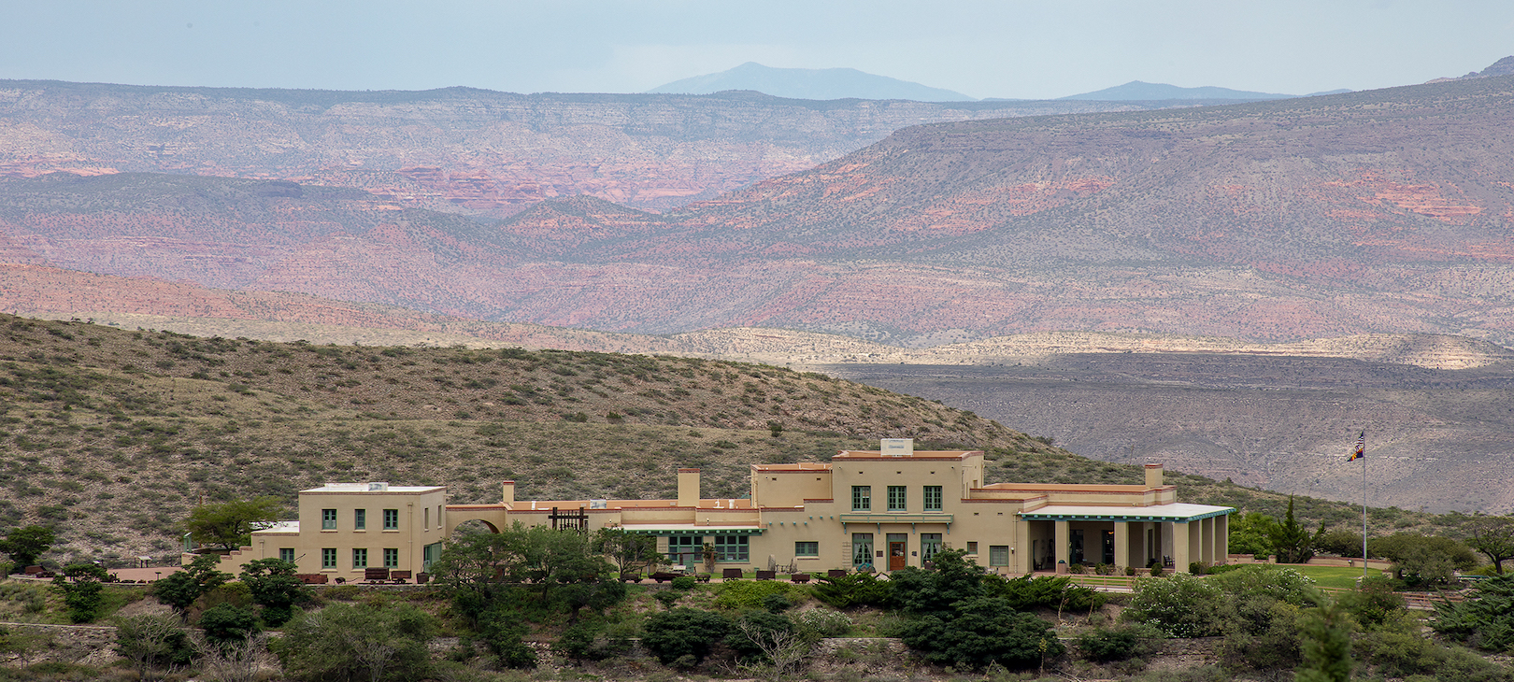

Jerome State Historic Park
100 Douglas Road Jerome AZ 86331
(928) 634-5381

FACILITY RENTAL INFORMATION
Jerome State Historic Park is pleased to make its amenities available for your special event. To help you
make your decision regarding the use of the Park, we ask that you study our guidelines carefully. Your
cooperation is needed in complying with the following regulations to ensure the success of your event, the
security of the facilities and the protection of the surrounding natural environment.

Reservations
Reservations for wedding ceremonies, receptions and other rentals are on a first come first serve basis.
Facility rental requires that you apply for a Special Use Permit.

Reservation Fee
NA

Special Use Permit
Arizona State Parks mission is to manage and conserve Arizona’s natural, cultural and recreational
resources for the benefit of the people, both in our Parks and through our Partners. Therefore to hold a
special event at the facility, Arizona State Parks requires a Special Use Permit. This agreement must be
completed, signed and returned to the Park at the time of booking your event.

Rental Space & Inclusions
The reserved area is for the use of the front lawn area.

Rental Hours
The Park facilities will be available only during the hours indicated in the Special Use Permit. All events
must end by 4pm, this includes clean up time.

Rental Fees & Payment Policy
Please refer to the Arizona State Parks Wedding Reservation Fees for complete cost information.
Balance of all charges is due 30 days prior to the event. No tax or service charge will be applied to the
rental fees. All deposits and payments may be made in the form of cash, credit cards, or debit cards.

Postponement of Event
Any change in the event date must be agreed to in writing by both Arizona State Parks and Permittee and
will result in a modification of the contract price to conform with the current rates. In the event all parties
agree to change the event date, all payments previously made towards the rental of the facility shall be
credited toward any remaining or additional charges.

Cancellation Policy
If a cancellation occurs fewer than 30 days in advance of the event, all deposits and fees are non-refundable
and no refund will be granted. Any cancellations made prior to 30 days before the event, will receive a
refund for any fees paid. Payments for events that are transferred (from one date to another) are nonrefundable regardless of cancellation date. Refund checks will be mailed within 6-8 weeks of receipt of
cancellation.

Inclement Weather
The Park assumes no liability for inclement weather that affects the event or for any occurrence that may
impact the event, which is outside the Parks’ control. You are responsible for any additional rentals
required to accommodate the needs of the event.

Event Representative
A responsible party must be designated as an Event Representative prior to the start of the event. It will be
the responsibility of the Event Representative to be available to answer questions and assist Park staff in
enforcing all rules and regulations and (s)he must check out with a Park staff member at the end of the
event before leaving the facility. The Event Representative must be at the Park during the entirety of the
event.

Rehearsal
The Park will allow a rehearsal of up to one hour in duration at no extra charge. Rehearsals must take place
during park operating hours.

Vendor Selection
The Park provides only the venue and limited rented equipment (tables, chairs, etc.). All costs of food,
floral, rentals, entertainment, and other features of the event are your responsibility.

Catering
N/A

Alcoholic Beverages
Alcohol is not permitted on the park. A champagne toast after the wedding is acceptable.

Music
DJs, acoustic and amplified music are permitted at the Park. The volume of music must remain at a level
satisfactory to guests and Park staff.

Photography
Photos are permitted throughout the Park.

Tenting
N/A

Deliveries (Personal and Rental)
All deliveries and pick-ups must be arranged with the Park staff. The Park does not have areas for the
storage of personal belongings or rental equipment. All deliveries must be the day of the wedding.

Equipment belonging to the Park
Banquet tables and chairs are available for an additional fee. You are responsible for ensuring that vendors
provide sufficient extension cords, generators, etc. to cover the event’s electrical needs. Failure to notify
Park staff of electrical requirements may result in inadequate power or power failure.

Decorations
No physical alterations may be made to any part of the Park’s facility or property. No doorway or public
corridor may be blocked in any way.

Clean Up
You are responsible for returning the rented area to original condition. All rental items, decorations,
flowers, personal belongings, etc. must be removed from the public areas immediately following the event
and be picked up from the park by 4PM the day of the event.

Flora & Fauna
For the safety of the wildlife and plants near the Park, please do not throw rice, birdseed, confetti, or similar
materials. Please leave the grounds as you found them.

Minors
Minors must be accompanied at a ratio of one adult to every 10 minors. An adult must be with a minor at
all times and are responsible for their safety and discipline.

Pets
Pets are not permitted in the building. Pets must be on a 6 foot leash at all times.

Smoking
Smoking is only permitted in the parking lot area.

Park Staff
A member of the Park staff will be on premises throughout your event. Park staff will provide assistance to
ensure event meets specifications outlined in the Special Use Agreement.

Frequently Asked Questions for Weddings at Jerome State Historic Park

Q: How many guests can the area comfortably accommodate?
A: The area can accommodate up to 50 people.

2. Q: Can the Park host more than one event at a time?
A: No, space is limited to use of the front lawn/picnic grounds.

3. Q: At what times may events be held?
A: We have not specified a length of time for weddings. Most weddings typically last around one
hour. No event shall extend beyond 4 p.m.

4. Q: What does the facility rental fee include?
A: The fees we are charging are for the rental of the lawn area and also includes admission to the
museum.

5. Q: Can I rent the facility for a ceremony only?
A: Yes.

6. Q: In case of inclement weather, what happens to an outdoor wedding?
A: Rental of tents from an area vendor.

7. Q: Is outside catering allowed?
A: The wedding party may have their own food, tables, chairs, and accessories brought in by an
outside vendor/caterer.

8. Q: Is there a specific list of other vendors?
A: Your choice of vendors is at your discretion.

9. Q: Are tables, chairs & linens included?
A: No, however tables and chairs are available to reserve for an additional fee.

10. Q: What is your alcohol policy?
A: No alcohol is permitted. A champagne toast after the ceremony is permitted.

11. Q: Is smoking permitted?
A: There is no smoking permitted within 20ft of the door.

12. Q: Is music allowed?
A: Yes, a DJ or live band is allowed. Volume levels must be kept to a reasonable level.

13. Q: When can I start setting up for my event?
A: You will be required to set up all requested tables and chairs before the event time and be given
1 hour of take-down time.

14. Q: Are there any restrictions on decorations?
A: Yes, no physical alterations may be made to any part of the Park’s facility or property. No
doorway or public corridor may be blocked in any way.

15. Q: What restrooms are available for event guests?
A: Park Restrooms.

16. Q: Is there a dressing room?
A: No/Restrooms only.

17. Q: Is there parking?
A: Yes.

18. Q: Is there handicap access?
A: Yes.

19. Q: How do I book an event and hold the date?
A: All reservations are made on a first-come first-serve basis. To secure a reservation, a Wedding
Special Use Permit Application must be completed, signed and returned to the Park. Also, a nonrefundable
reservation deposit of $ 25 is due at the time of booking, which will be applied towards
the total balance.

20. Q: What forms of payment do you accept?
A: We accept cash, credit cards, debit cards, or any combination of the above.

21. Q: When is payment due?
A: The reservation deposit is due 15 days in advance of the wedding. The full amount is due the
day of the wedding.

22. Q: How far in advance do you need to make reservations?
A: As soon as possible, up to one year in advance.

23. Q: Do you offer overnight accommodations?
A: No.

24. Q: Are weapons allowed at your venue?
A: Follow ASP Policy

25. Q: Are there adequate bathroom facilities for large groups?
A: Yes.

26. Q: Are any other permits required from the city/county?
A: No.

27. Q: What is your policy for dress rehearsals? Are the wedding party allowed to use the facility for
this purpose prior to the wedding?
A: Rehearsals are permitted.

28. Q: Is there an extra charge for any amenities/facilities?
A: No.

29. Q: Is there a cleaning fee?
A: No.

Thank you for considering using Jerome State Historic Park for your wedding ceremony!

